16 Sept 2020 Rinoy Kuriyakose R3 56

Experiment:4

Design a class to represent a bank account. Include the following members.

Data Members:

Name of the depositor

Account Number

Type of Account

Balance amount in the account

Methods

To deposit an amount

To withdraw an amount after checking balance

To display the name and balance

Incorporate default and parameterized constructor to provide initial values

Program:

public class BankAccount {  
 String Name;  
 int AccNumber;  
 String AccType;  
 float Amt;  
  
 BankAccount() {  
 Amt = 0;  
 }  
  
 BankAccount(String n,int ac,String t){  
 Name=n;  
 AccNumber=ac;  
 AccType=t;  
 }  
 void deposit (float a){  
 Amt=a;  
 System.out.println("------DEPOSIT------");  
 System.out.println("Rs"+Amt+" Deposited Sucessfully");  
 }  
 void withdraw(float w){  
 System.out.println("\n\n------WITHDRAWAL------");  
 System.out.println("Your Balance : "+ Amt);  
 Amt=Amt-w;  
 System.out.println("Transaction of Rs"+w+" is Sucessful");  
 System.out.println("Your Remaining Balance : "+ Amt);  
 }  
 void info(){  
 System.out.println("\n\n------INFO------");  
 System.out.println("Your Name : "+ Amt);  
 System.out.println("Your Account Number : "+AccNumber);  
 System.out.println("Your Account Type : "+ AccType);  
 System.out.println("Your Balance : "+ Amt);  
 }  
 public static void main (String args[]){  
 BankAccount Acc1=new BankAccount("Rinoy",123456,"Savings");  
 Acc1.deposit(10000);  
 Acc1.withdraw(1000);  
 Acc1.info();  
 }  
}

Output:

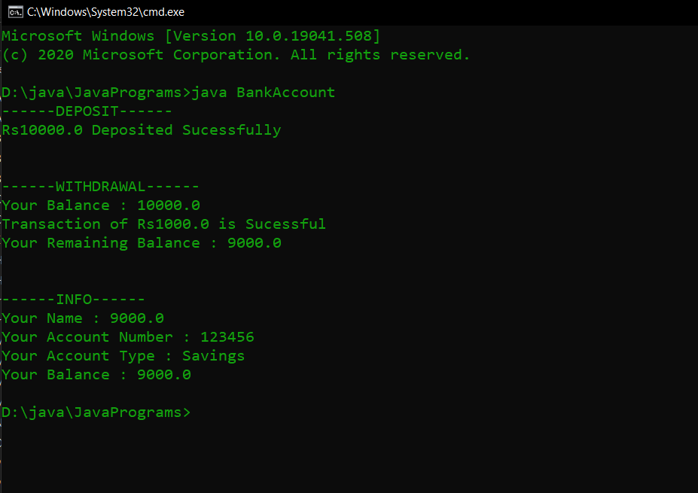

16 Sept 2020

Experiment:5

Write a Java program which creates a class named 'Employee' having the following members: Name, Age, Phone number, Address, Salary. It also has a method named 'printSalary( )' which prints the salary of the Employee. Two classes 'Officer' and 'Manager' inherits the 'Employee' class. The 'Officer' and 'Manager' classes have data members 'specialization' and 'department' respectively. Now, assign name, age, phone number, address and salary to an officer and a manager by making an object of both of these classes and print the same.

Program:

class Employee{  
 String name;  
 int age;  
 String phoneNumber;  
 String address;  
 double salary;  
 public void printSalary(){  
 System.out.println("Salary = $"+salary);  
 System.out.println();  
 }  
 Employee(String a, int b, String c, String d, double e){  
 name=a;  
 age=b;  
 phoneNumber=c;  
 address=d;  
 salary=e;  
 }  
}  
public class Manager extends Employee{  
 String specialization;  
 String department;  
 Manager(String a, int b, String c, String d, double e,String f){  
 super(a,b,c,d,e);  
 department=f;  
 }  
 public void printInfo(){  
 System.out.println("--- Manager Information ---");  
 System.out.println();  
 System.out.println("Name = "+name);  
 System.out.println("Age = "+age);  
 System.out.println("Phone Number = "+phoneNumber);  
 System.out.println("Address = "+address);  
 System.out.println("Department = "+department);  
 System.out.println();  
 }  
 public static void main(String args[]){  
 Manager m1 =new Manager("Alexis",26,"9913891231","East City London UK",9000,"Sales");  
 Officer o1 =new Officer("John" ,28,"9671290231","Los Angeles New York US",5000,"Cyber Security");  
 m1.printInfo();  
 m1.printSalary();  
 o1.printInfo();  
 o1.printSalary();  
 }  
  
}  
class Officer extends Employee{  
 String specialization;  
 Officer(String a, int b, String c, String d, double e,String f ){  
 super(a,b,c,d,e);  
 specialization=f;  
 }  
 public void printInfo(){  
 System.out.println("--- Officer Information ---");  
 System.out.println();  
 System.out.println("Name = "+name);  
 System.out.println("Age = "+age);  
 System.out.println("Phone Number = "+phoneNumber);  
 System.out.println("Address = "+address);  
 System.out.println("Specialization = "+specialization);  
 System.out.println();  
 }  
}

Output:

